
  - Patient Advocate in Cancer Research Award 2024
Application Form

My details
Cancer Research Advocacy Background
If you don’t know if your experience relates to cancer research advocacy, please contact grants@irishcancer.ie. If you are a new patient advocate, it is understood that you will not have previous experience
Full name:
Contact number:
Postal address:
Would you like to be notified of your result by email, phone or post?
Do you have experience as a cancer research advocate? If you don’t, please move on to the next section. If you do, please describe what you’ve done in the past as a cancer research advocate. You can use bullet points. (Max. 300 words).

The cancer research event/ activity details I am interested in
Name of event/ activity
Name of the conference, funding panel, workshop or PPI activity. If there is no official name, please put in a short description of the event.

Nature of the event/activity and description
A short description of the event or activity (max 250 words)

Location
City/Town, Country

Duration Dates
First day of event until last day of event

Dates that you plan to attend the event
Do you plan to attend the whole event or only specific days?

Website of event
If there is no dedicated website, please enter the details of any website where there is information on the event or activity

Are you planning to attend more than one event/ PPI activity? You will be asked to provide the same information as Sections b), c), d) and e) for the additional event. If you are typing, please copy and paste the sections. If you are handwriting, continue writing on the back of the page or a new page.
If yes, please explain why you are attending multiple events

Is there funding available for you from any other organisation for the event? For example, from the event organisers?
If yes, please give details:

Benefits of going to the event or undertaking these PPI activities (max 500 words total)
Why you chose this event
What are the parts of the event that you feel would be best for you? This could include specific sessions, or attendees, speakers you wish to network with and more.
What are the knowledge and skills you hope to gain by going to the event? Why is this important for the role of a cancer research advocate?
Are there connections you hope to make at the event? If so, why is this important for the role of a cancer research advocate?

What should my budget include?

Budget Guidelines
We can cover the following costs for you:
- Travel, accommodation and meals
- Costs associated with childcare, carers and loss of earnings
- Registration/course fees
- Running costs such as materials and administration costs

Reasonable expenses are those that are cost-effective and needed for the event. It also considers your needs. For example, taking taxis due to health reasons. More information is provided in the ‘Guidelines’ document.
If you are selected for the award, we will send you 70% of the total requested amount to book accommodation and travel. You will get the rest (30%) of the amount after we get the report covering the event(s) from you. Payments will be made directly into your bank account.
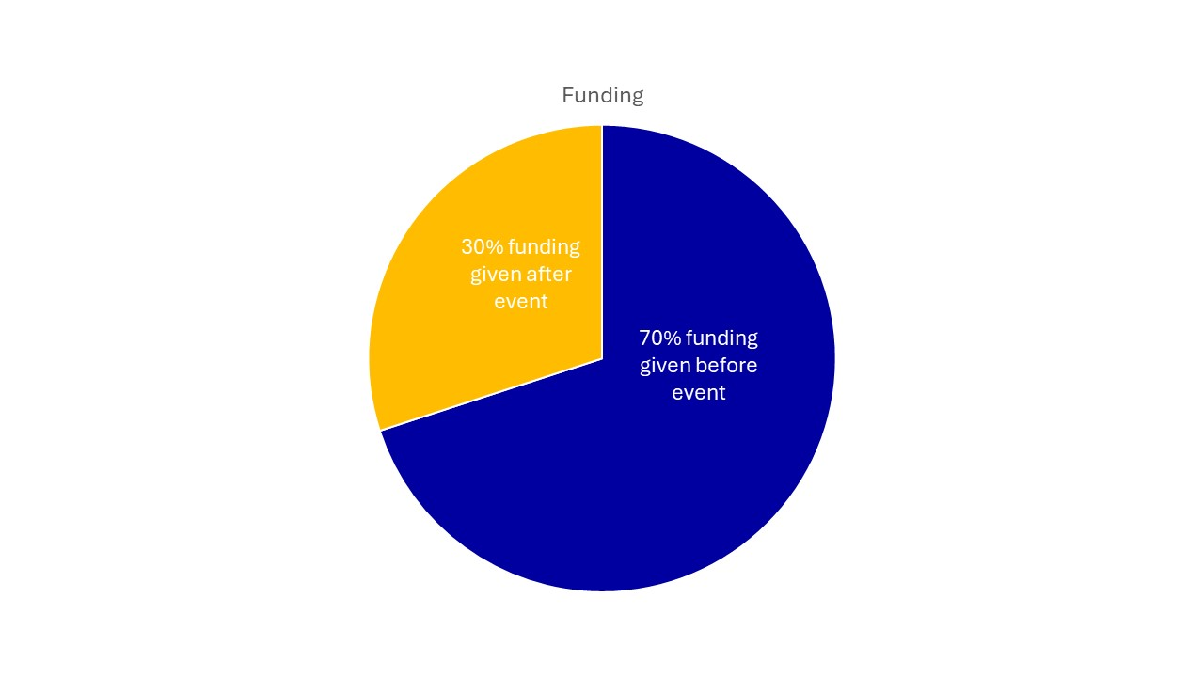

Completing the Budget Application
In the table below, you will need to describe each cost, and why you need each cost. You should include your calculations for each cost in your budget (e.g., “I will need breakfast €10 and lunch €12 when at the event, so €22 total for meals).
We understand that costs may vary, so this is an estimated budget. However, we ask that you try your best to give accurate costs.
- If attending an event, we ask that before writing this section you look up registration costs for the event (if needed), the cost of travel (for example, buses, trains, air fare… and so on) and the average price of accommodation in that location.
- If attending a PPI activity, we ask that you look up the cost of travel (for example, buses, trains… and so on), and consider any materials needed.
Please also consider any other costs that you may need to budget such as loss of earnings, childcare costs, carer costs and meals and so on.

Example budget:

Description | Amount (€)
Travel:  Return bus to/ from the airport  Ryanair (FR314) return flights to Amsterdam, Holland (24/6/25 – 26/6/25) | 4  140
Accommodation:  NH Amsterdam Zuid (24/6/25 – 26/6/25) | 280
Meals:  Lunch x 2  Dinner x 2 | 24  50
Other expenses (please describe):  Childcare while I am away for three days | 210
Running costs:  Notebook and pens | 7
Registration/ course fees:  Breast cancer research symposium (24/6/25 – 25/6/25) | 250
TOTAL: | 965

Your budget:
Description | Amount
Travel:

Accommodation:

Meals:

Other expenses (please describe):

Running costs:

Registration/ course fees:

TOTAL:

Where do we get our funds from?
The Irish Cancer Society is the largest voluntary funder of cancer research in Ireland. Over 95% of our funds are raised through public donations. We are committed to making sure all funds are used sensibly and appropriately.

You should post or email your application to us before the deadline, but we understand that issues can come up, so do get in touch if you need more time (grants@irishcancer.ie or (01) 968 3723).

